Let’s create a game!

# Creating A New Scene

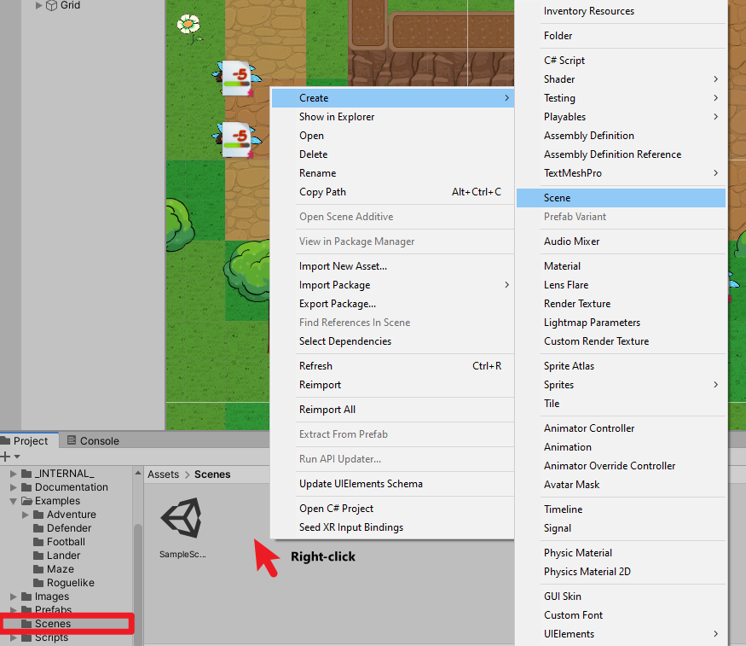

In the Project view, we’ll go to ‘Scenes’ folder and right-click to create a new scene.

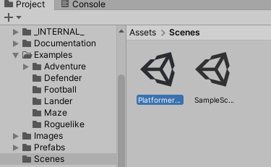

We’ll rename this scene to be “Platformer Game”. Let’s double-click on the scene to open it.

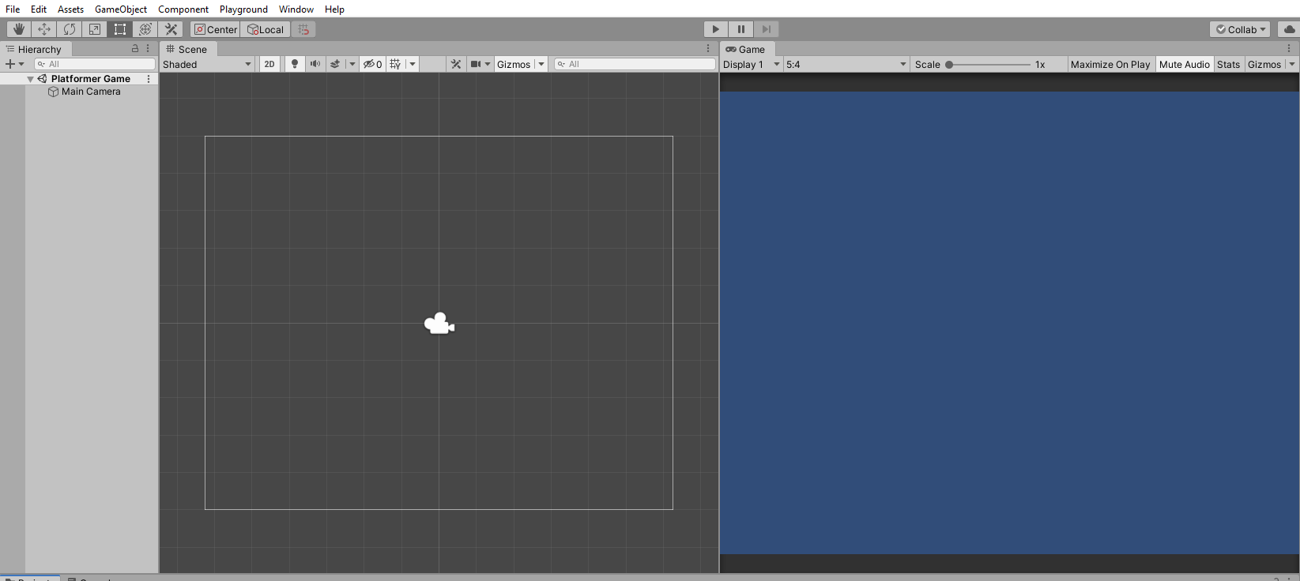

# Importing Background Image

Go to Assets > Images > Backgrounds, then drag one of the images into our Scene view.

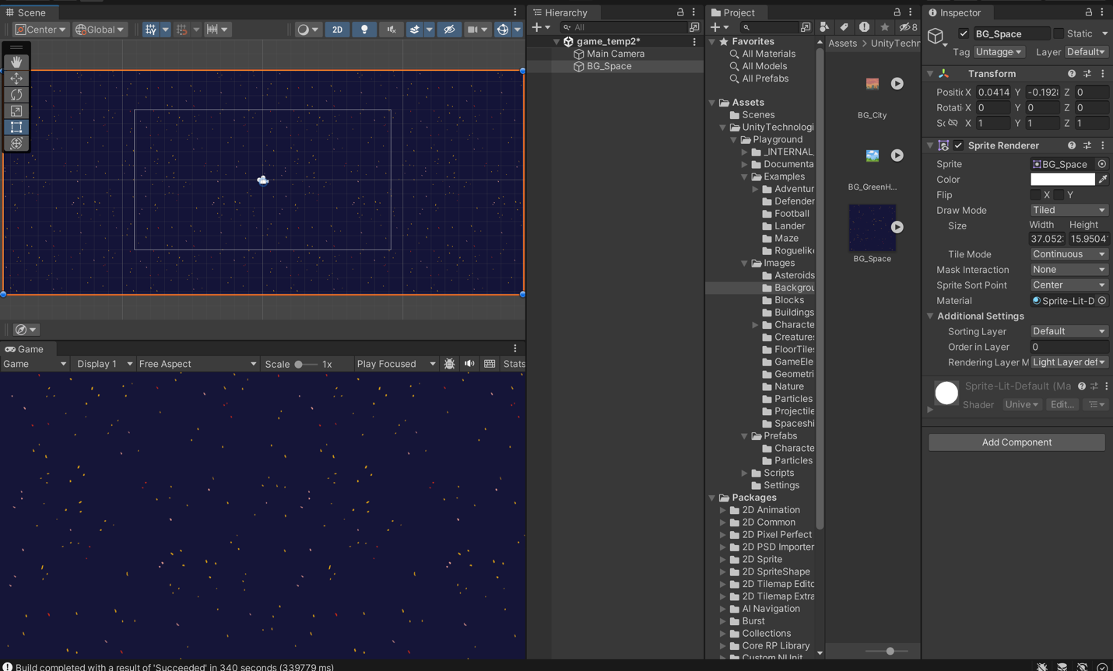

In the Hierarchy view, you can see that there are two objects in our scene: Main Camera and the image we just added in.

Go to File > Save (or press Ctrl+S/CMD+S) to save the scene.

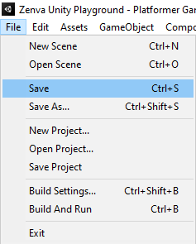

Resizing The Background

With the Background object selected, you should see that there are two components (i.e. Transform & Sprite Renderer) in the Inspector. (If it seems different on your screen, it might mean that the playground is not enabled. Make sure it is enabled, and reload the inspector.)

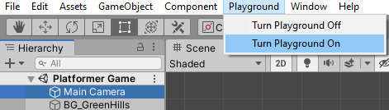

To expand the background to fit our screen size, we’re going to set the Sprite Renderer > Draw Mode to be ‘Tiled’.

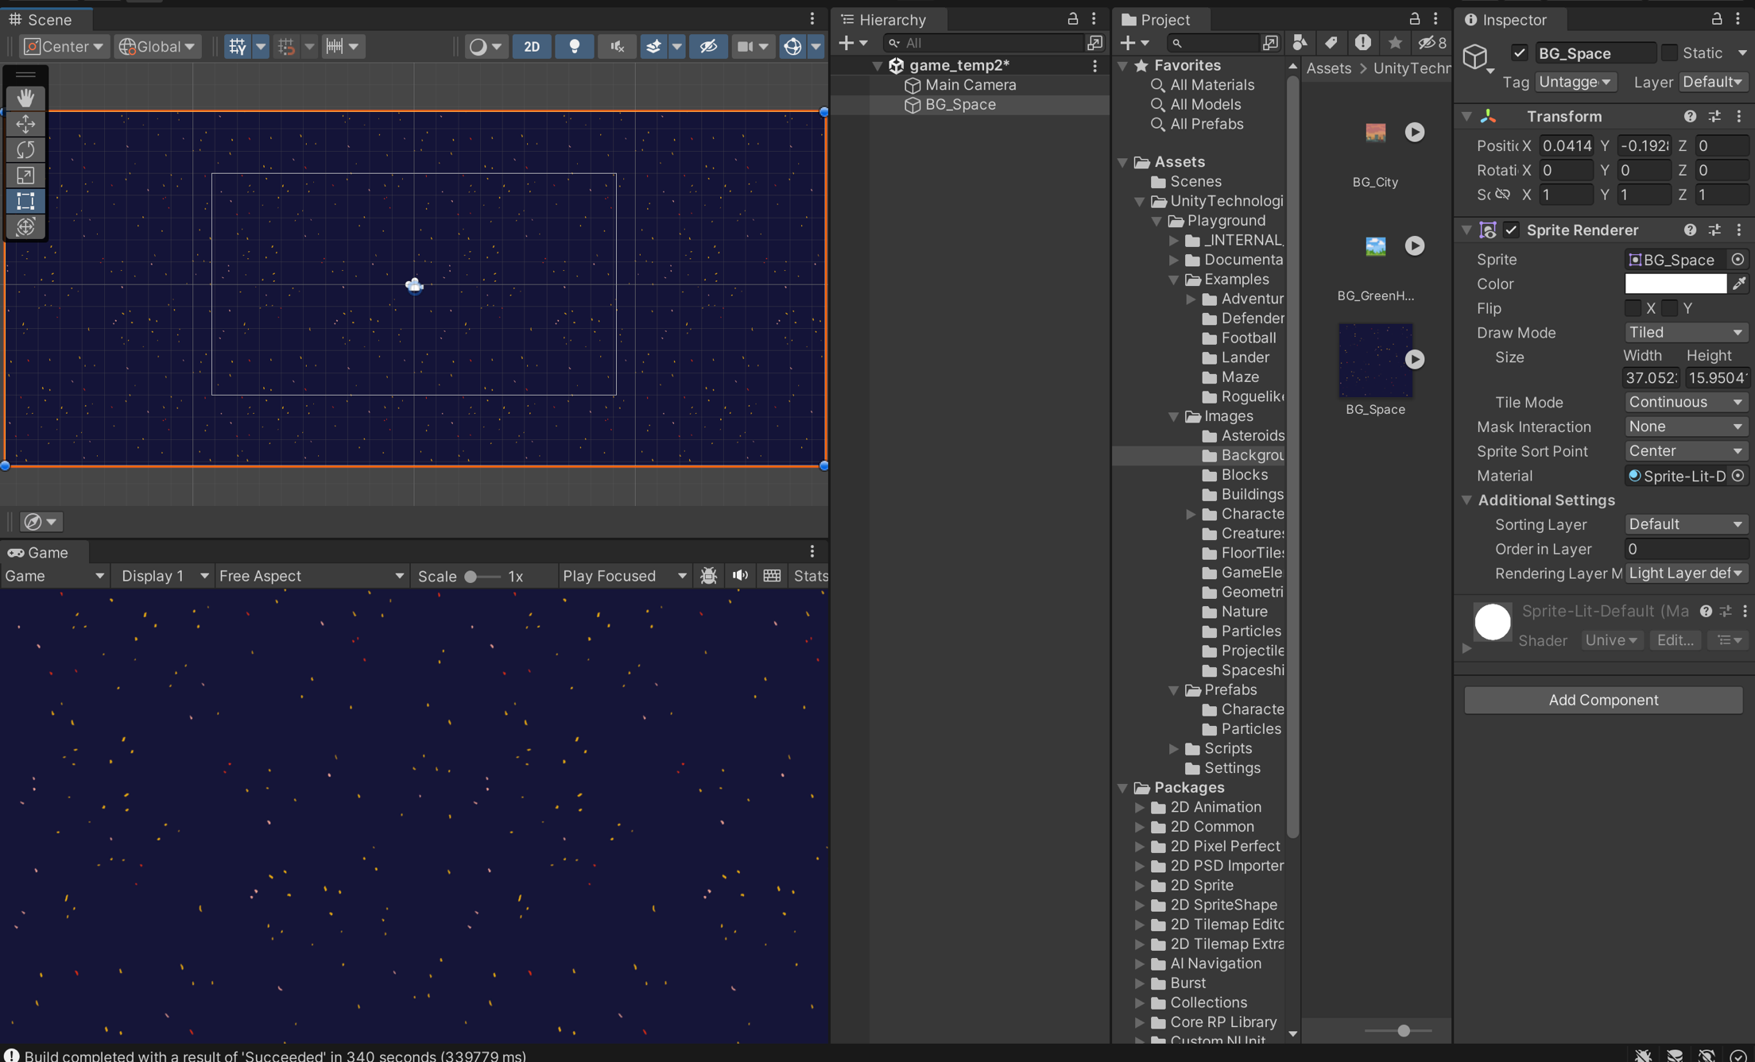

We’ll also set the Visibility Options > Sorting Layer to be “Background” to make sure that our background image is always positioned behind other objects.

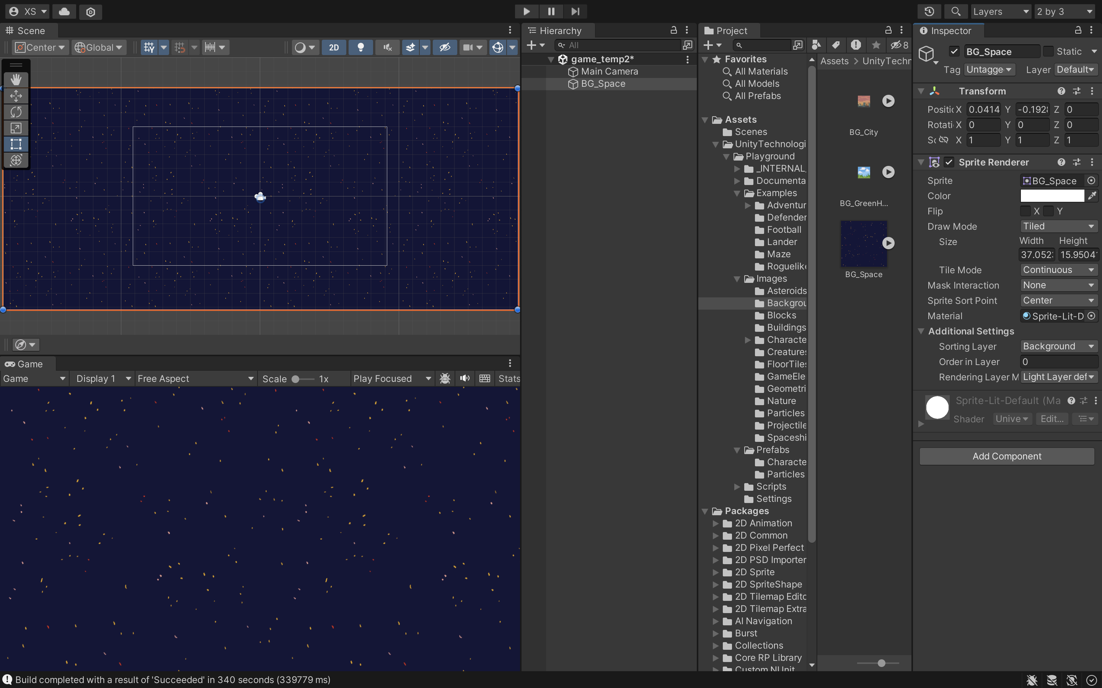

# add a player to our game

Importing A Sprite

Go to Assets > Images > Creatures and drag in one of the sprites onto the Scene view.

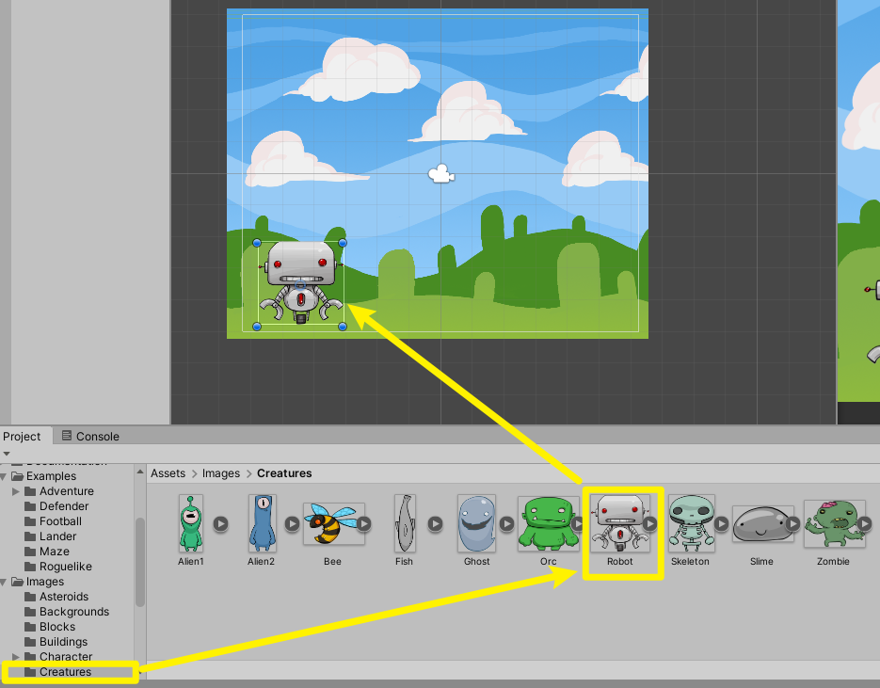

Select the Hand tool to move our camera around the scene view. (Alternatively, you can drag while holding the middle mouse button)

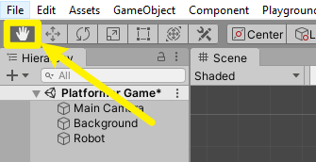

Editing Transform

To move a GameObject around the scene, you can select the Move tool or type values directly into the number fields of the Transform component in the Inspector.

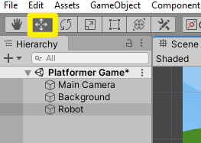

Applying Gravity

To make our player fall with gravity, we’re going to add a Rigidbody2D component to our gameObject.

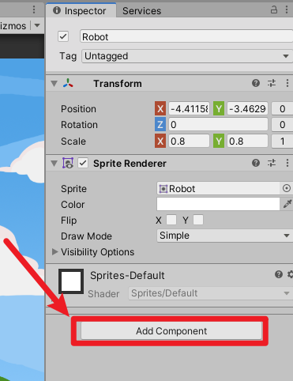

Click on ‘Add Component’ in the Inspector, and search Rigidbody2D.

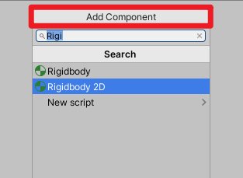

Adding Ground

Let’s go to Assets > Images > Blocks and drag in one of the sprites into our scene.

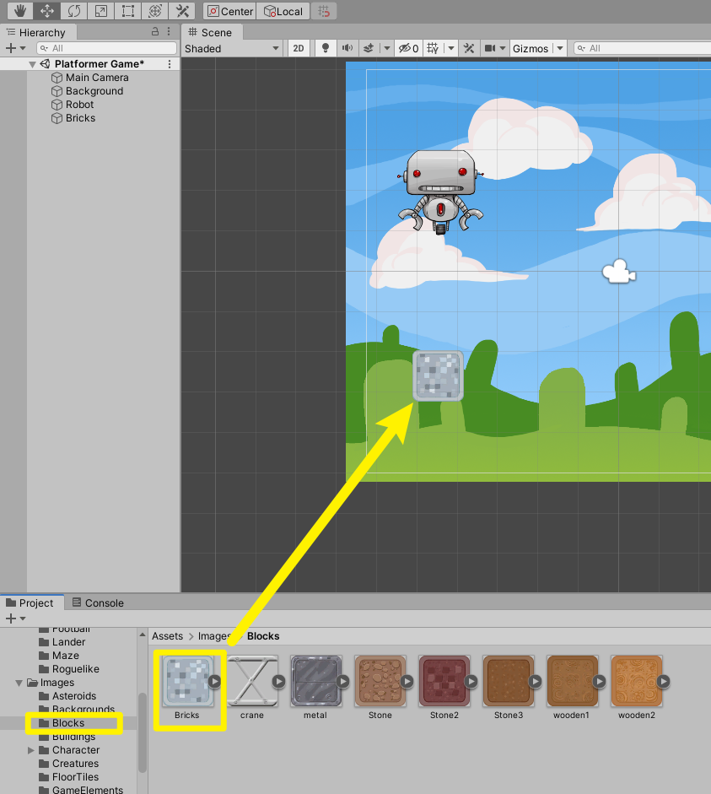

If you press Play, you’ll see that the Player still falls through the ground. This is because we need to add something called a collider to both the Player and the ground.

Let’s select our brick image, and click on Add Component > Box Collider 2D.

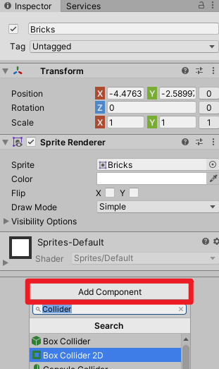

The collider component is now added to our ground object. You’ll see that there’s a green boxshaped outline appearing in the scene view.

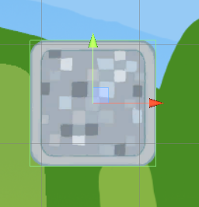

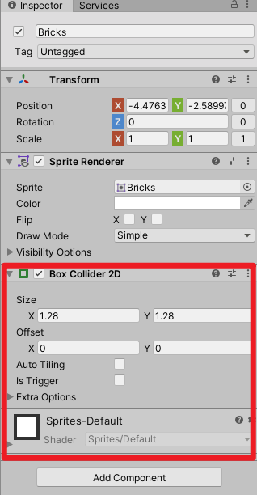

Let’s click on our Player, and add a CapsuleCollider2D.

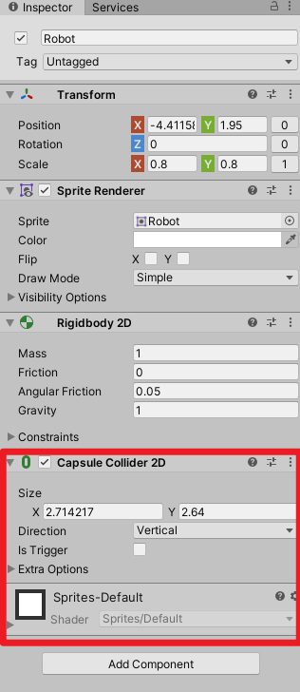

If we press Play, the player now gets stopped by the ground.

# implement player movement

Before we begin, we’re going to rename our player object from “Robot” to “Player” and also resize its scale to (0.4, 0.4).

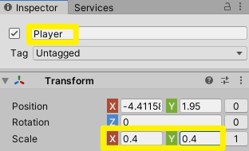

Adding Move With Arrows

Next, we’re going to add a component called “Move With Arrows“ or “Move”.

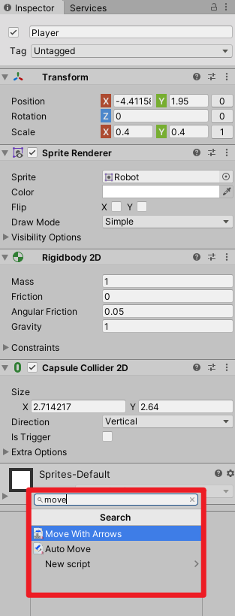

Let’s click on the Movement Type property and set it to be Only Horizontal.

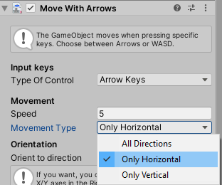

We can prevent it from rolling like a ball by freezing z-rotation in the Rigidbody2D settings.

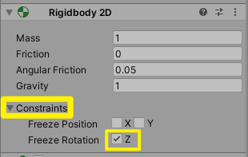

If you think it’s moving too fast, you can set the speed in the Move With Arrows settings.

Now we’ll duplicate our block by pressing Ctrl/Cmd + D.

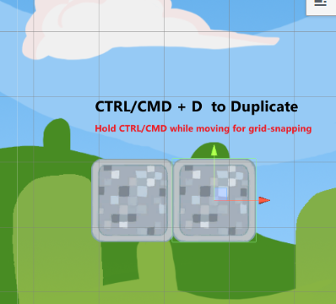

Adding Jump

To implement an ability to jump, we’ll simply add a component called Jump to our player gameObject.

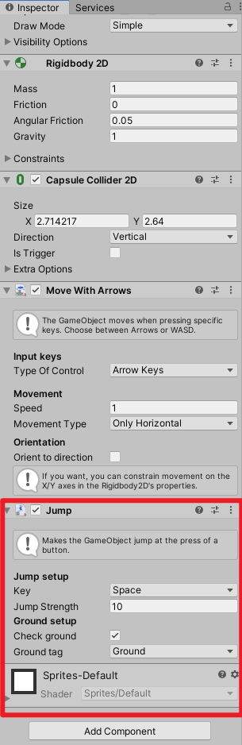

This component has a property called ‘Ground tag‘; this means we need to select all the bricks and assign a tag called “Ground”. (For selecting a range of game objects, hold down the SHIFT key, and select the last item.)

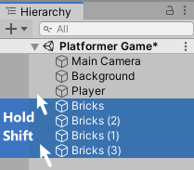

Click on ‘Untagged’ and select ‘Ground’.

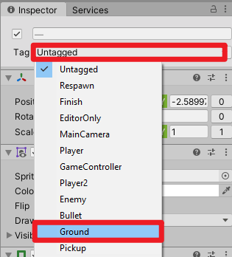

# add collectible stars

Adding HUD Prefab

First, we’ll add the functionality of keeping track of player scores and player lives.

Let’s open up Assets > Prefabs folder.

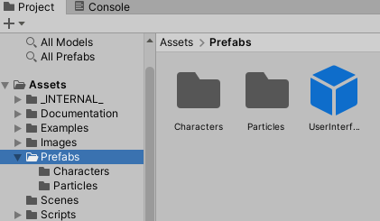

Select the prefab called UserInterface and drag it into our hierarchy.

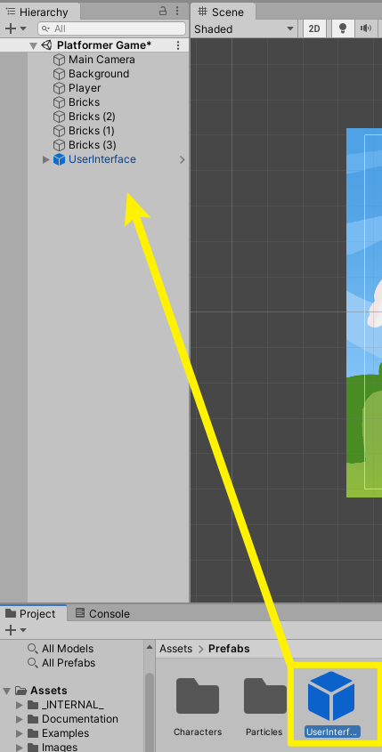

This will create this HUD showing the number of player health and scores.

Now, select the player gameObject and assign a tag called ‘Player’.

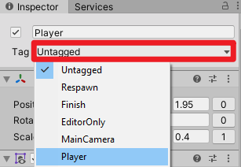

This is so that Unity can know that this is the player that we’re going to be keeping score.

Let’s adding a component called Health System.

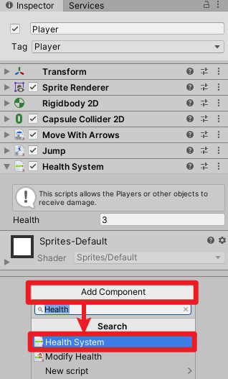

Adding A Collectable

Open the Assets > Images > GameElements folder, and you will find a range of images here.

We’ll drag in the Star image into our scene.

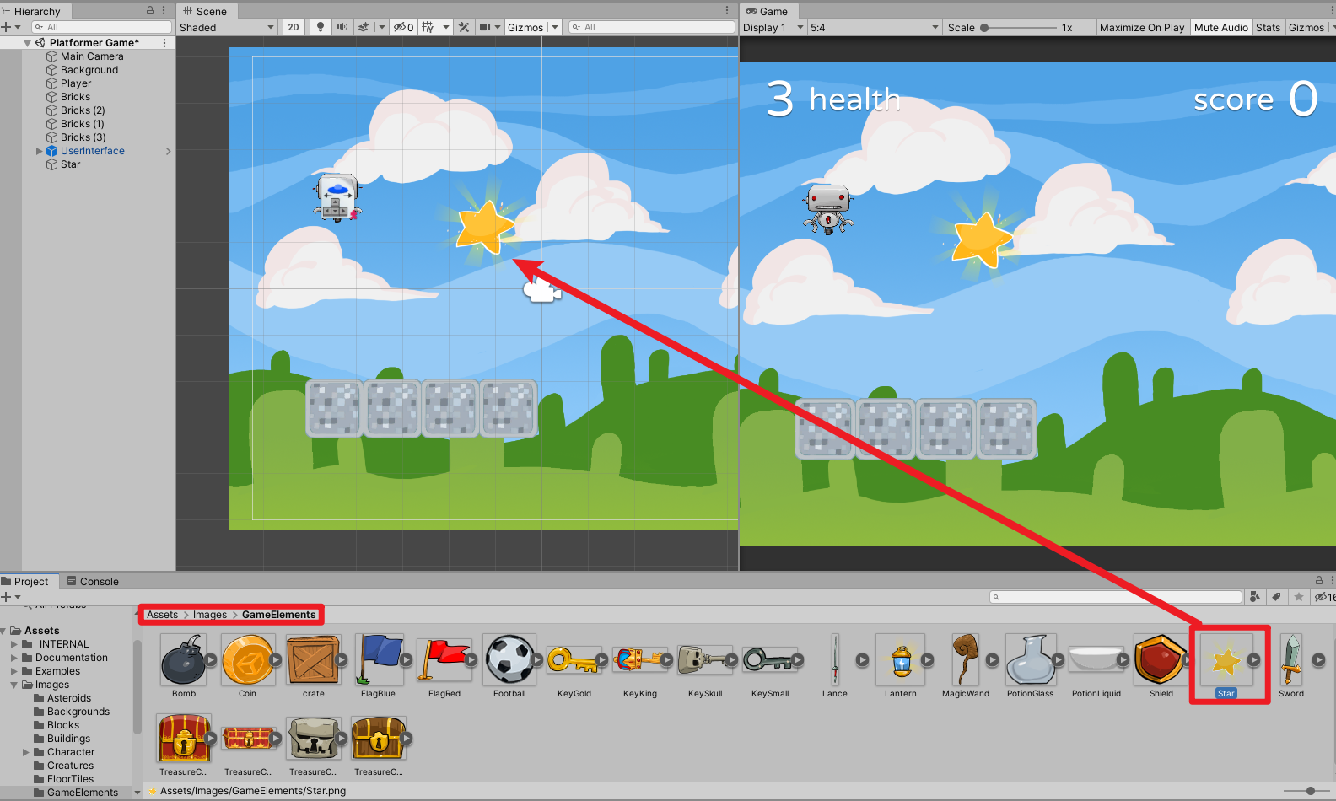

We’ll add a component called Collectable…

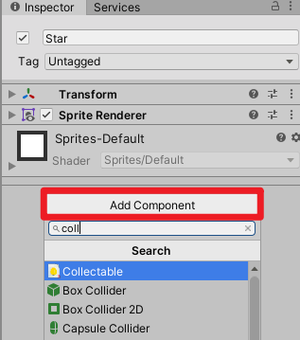

…but it will warn us that we need to have a collider2D first. This is because we need to be able to detect collisions, so we know when the player hits the star.

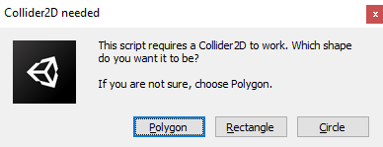

Let’s pick Polygon, and we can see that two components were added– Collectable and PolygonCollider2D.

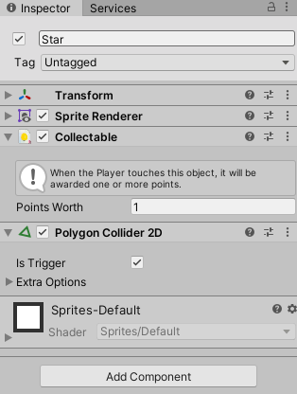

# Creating Cliff Check

First, we’re going to check whether the player has fallen off the cliff.

Let’s right-click the Hierarchy, and select Create Empty.

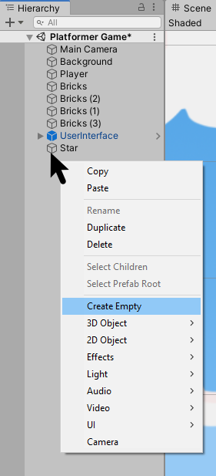

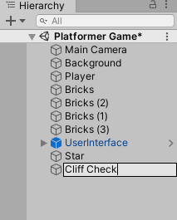

Let’s select the Move tool and move it to the bottom center of the screen.

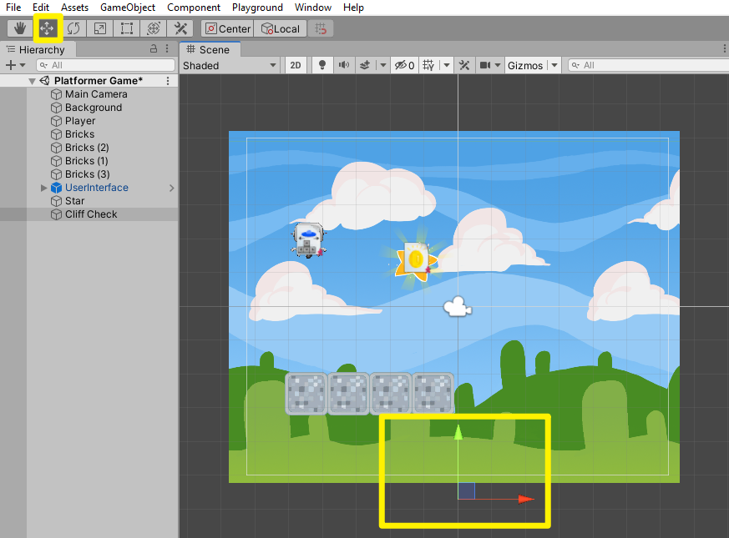

Adding Collider to Cliff Check

Now, we’re going to add a BoxCollider2D to check collision and set the size of the collider so it can cover the width of the game screen.

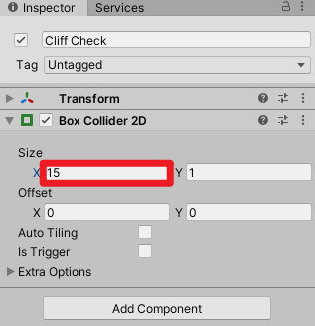

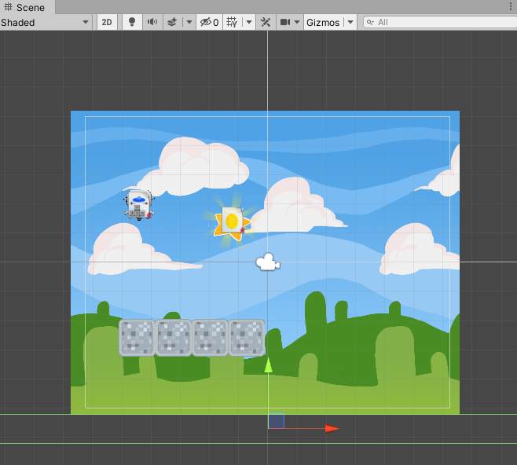

Adding Health Modifier to Cliff Check

Let’s add a component called Modify Health. This is part of the Unity Playground, which will modify the health system attached to other gameObjects.

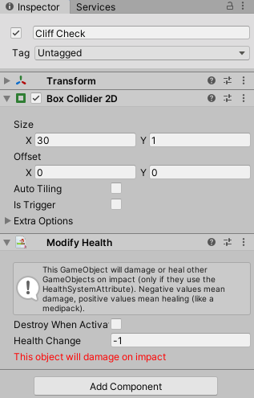

Now if we press Play, you’ll see that the player’s health decreases as it falls off the cliff, but the player gets stuck there.

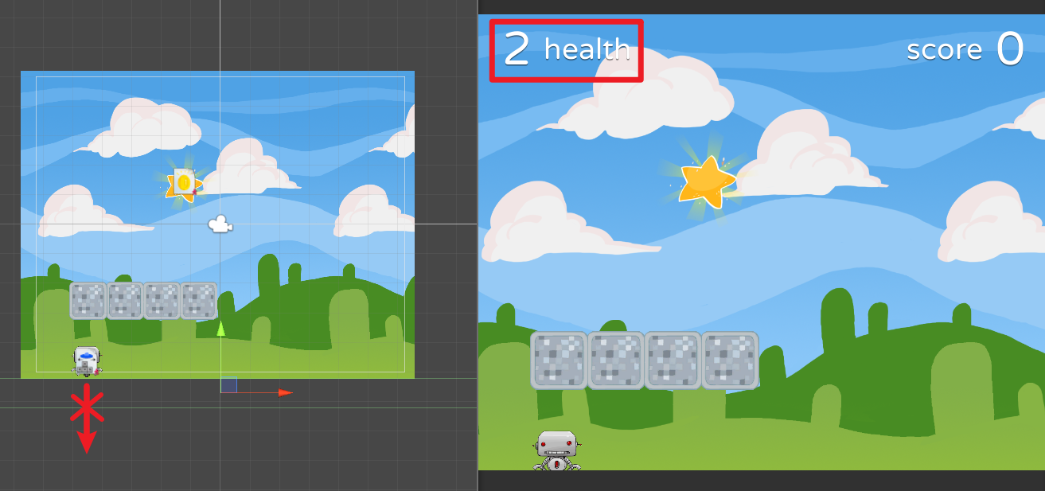

Adding Collision Event to Cliff Check

We need to make the player go back to the beginning. To do this, we’re going to add a component called Condition Collision to our Cliff Check gameObject.

This allows a certain event to occur when the player hits the object.

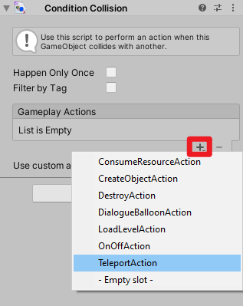

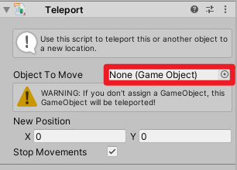

Now we have this new Teleport component added. We’re going to grab our player and drag it into the Object To Move field.

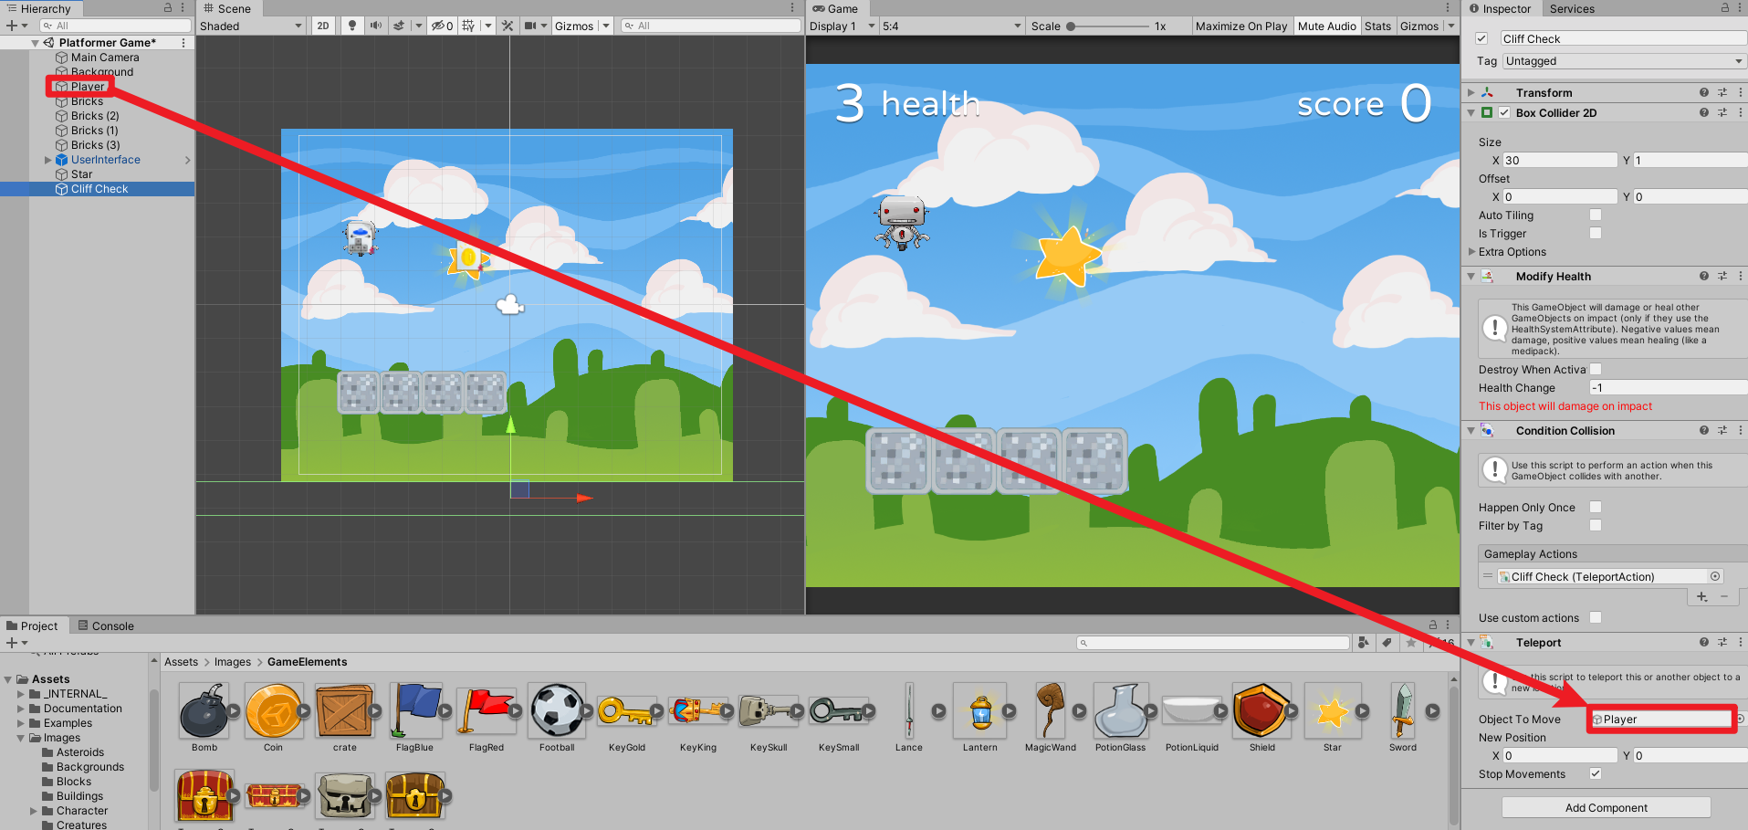

Also, take note of the player’s current position, and put it in the New Position field of the Teleport component. This allows the script to teleport our player back to its initial position.

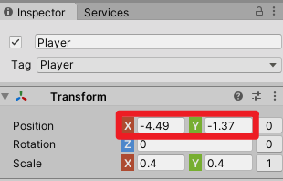

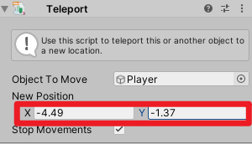

# Adding An Enemy Sprite

Let’s go to Assets > Images > Creatures

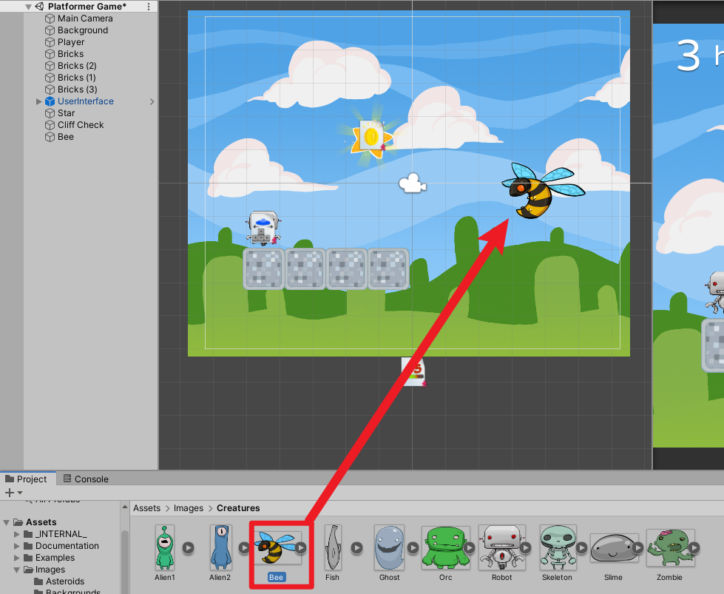

Adding A Collider

The enemy needs to have a collider so it can hit the player.

Let’s add a Polygon Collider 2D component to our enemy, and enable the ‘IsTrigger‘ property.

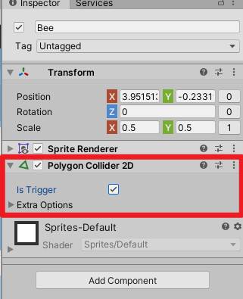

Setting it as a trigger allows it to go through other objects.

Adding A Health Modifier

Now, let’s add a Modify Health component so it can damage the player’s health.

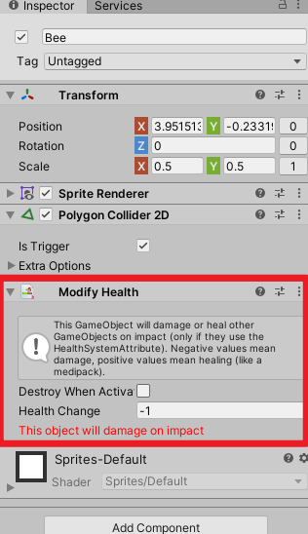

Adding A Wander Component

Lastly, let’s add a Wander component that will make this enemy move around.

We’ll change the speed to 0.2 and the direction change interval to be 0.5.

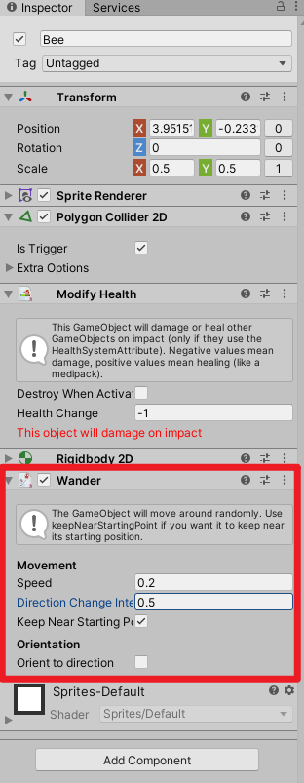

If you hit Play now, you’ll notice that the enemy immediately falls to the ground. This is because we have a Rigidbody2D component that has Gravity enabled.

Let’s set the gravity to 0, and now we can see that the enemy is moving around.

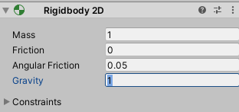

# Setting Camera Follow

Select the camera and add a component called CameraFollow.

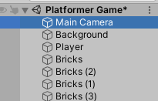

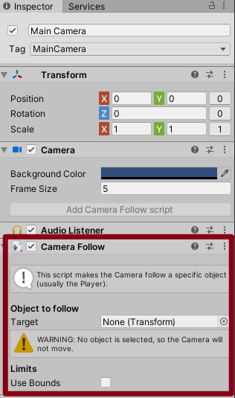

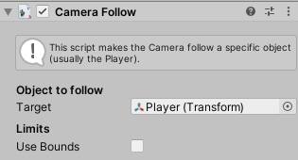

Now if we press Play, we can see that the camera is following the player. But if we fall off the cliff, we can see the bottom of the level that we should not be seeing. For this, we’re going to click on the ‘Use Bounds‘ field, which allows us to limit how much the camera will be able to show.

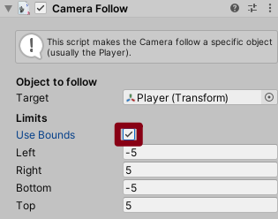

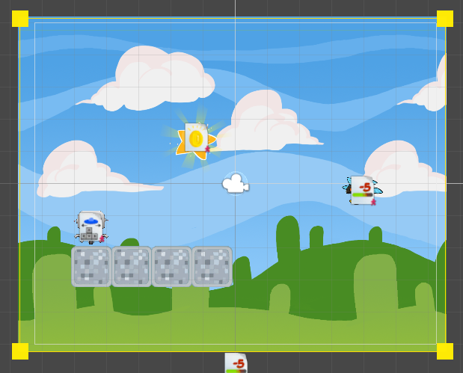

# implement a restart button

Creating An Empty GameObject

Let’s go and create an empty game object, (Right-click > Create Empty), and rename it to be ‘Restart Game’

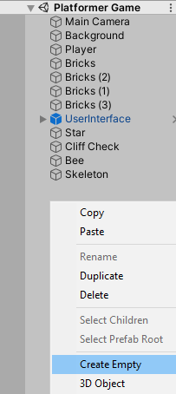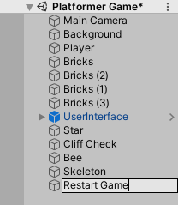

Adding A Scene Reloader

Then we’re going to click on Add Component > Condition Key Press.

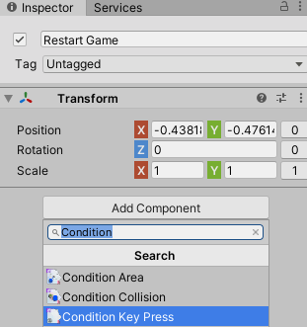

This component will allow us to run a certain action when a certain key is pressed.

We’re going to set the Key To Press to be the ‘Return’ key, and click on the + button to add a new LoadLevelAction.

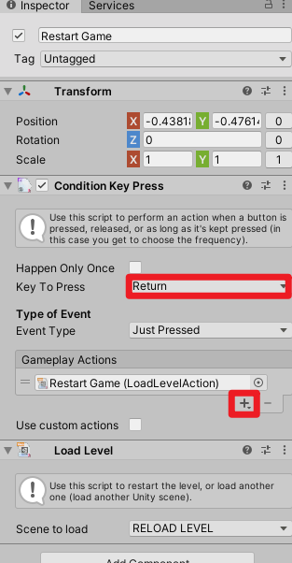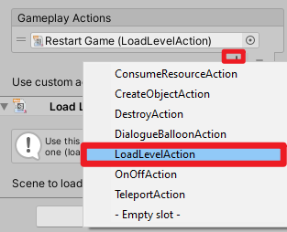

Now if you hit Play and press enter, it will reload the current level!

Finding The User Interface

Let’s select the UserInterface gameObject and press F to bring it to view.

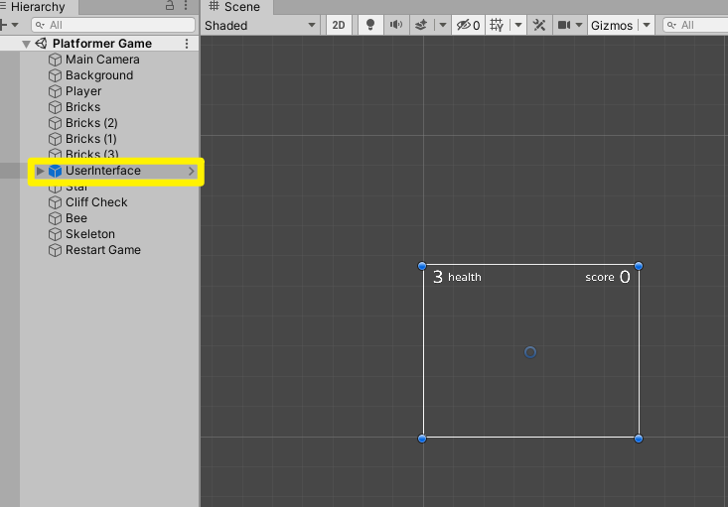

Now, let’s expand the UserInterface game object by pressing the highlighted arrow.

As you can see, there are two disabled children objects called “WinPanel” and “GameOverPanel”.

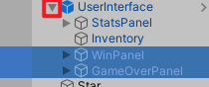

You can click on the checkbox in the Inspector to enable it and see what it looks like when it’s set to be active.

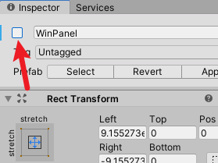

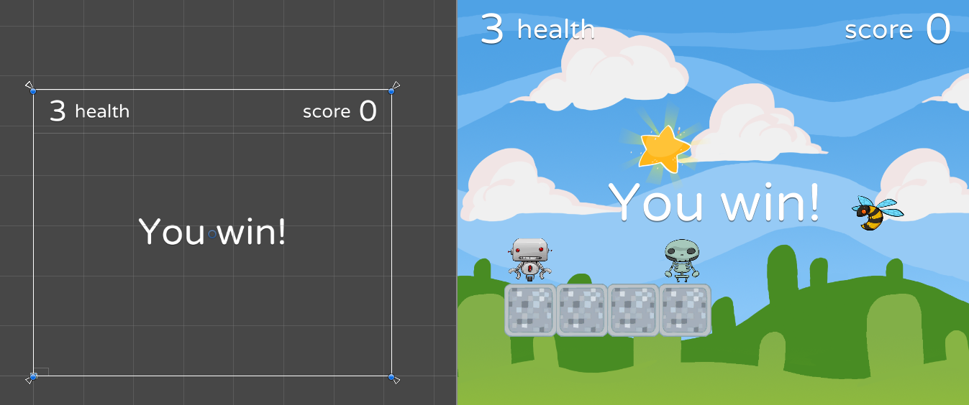

Adding In Another Label

Let’s duplicate the label by pressing Ctrl+D, and move it slightly down so we can see it.

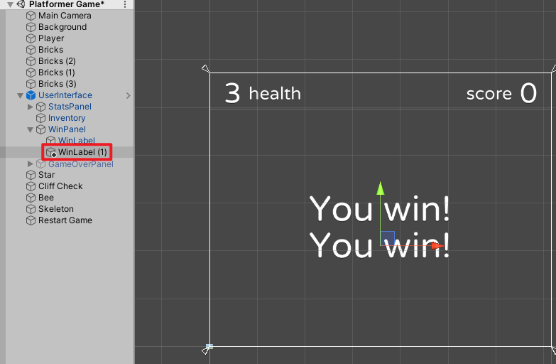

We’re going to change the text to be “Press ENTER to play again”, and set the font size to be 50.

We’re also going to rename this object to be “PlayAgainLabel”.

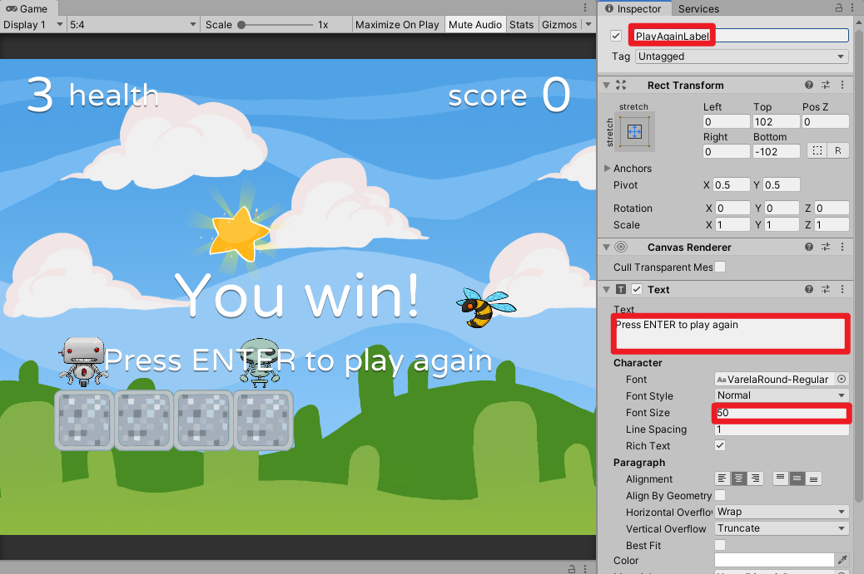

Let’s duplicate this gameObject again and drag it into the GameOverPanel.

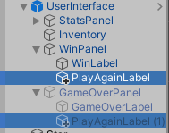

And lastly, we’re going to put both the WinPanel and GameOverPanel back to be in a disabled state.

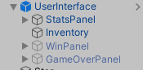

Now, if we hit Play and lose all our health points, we can see this new label on the game over screen.

Powered by TCPDF (www.tcpdf.org)

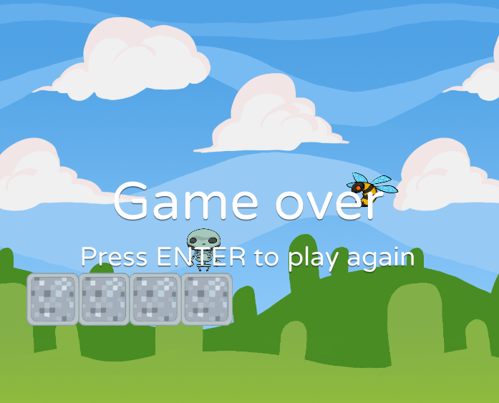

# Selecting Scenes To Build

Let’s go to File > Build Settings (Ctrl+Shift+B).

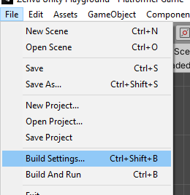

In the Build Settings window, we can select what scenes are going to be included in our build.

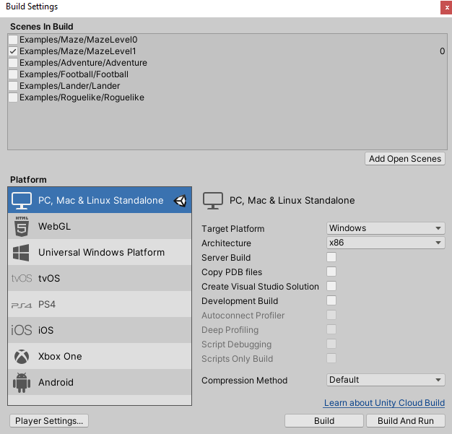

By default, we’re seeing all of these example games. However, we’re not going to export any of them, so let’s select all (Ctrl+A) and press Delete.

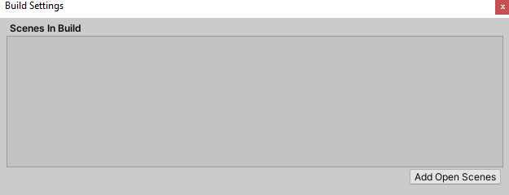

Now, let’s go to Assets > Scenes and drag our PlatformerGame into this area.

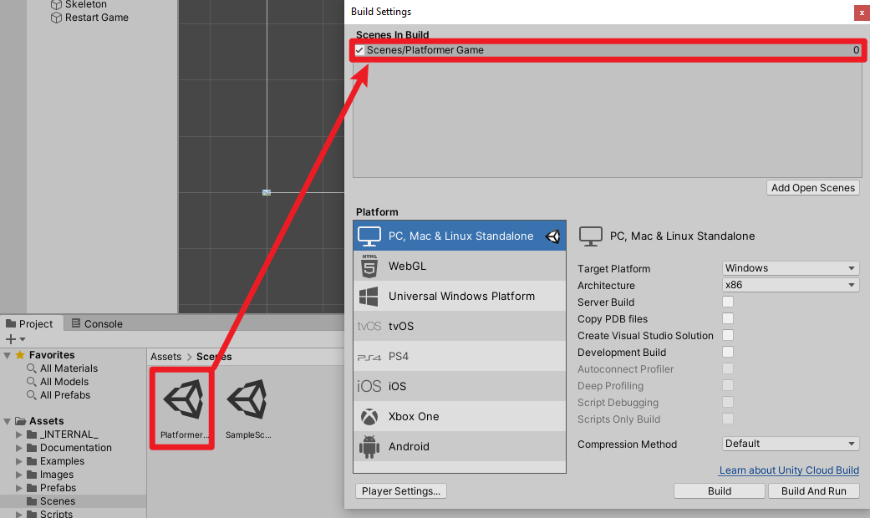

Selecting Target Platform

Now, we have to select the target platform. We will be using Windows as our target platform in this case, but if you’re on a Mac, you have to pick Mac.

